43.54: a) The energy of the alpha particle is 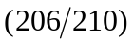times this, or 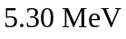(see Example 43.5)
b) 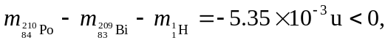 so the decay is not possible.
c)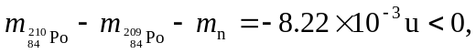 so the decay is not possible.
d)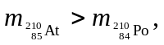 so the decay is not possible (see Problem (43.50)).
e)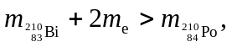 so the decay is not possible (see Problem (43.51)).

